Addressing the credibility gap:
A principled approach to setting Annex I aggregate reductions and closing loopholes in the Kyoto Protocol

Lim Li Lin, Third World Network

Annex I countries are committed under the UN Climate Convention to demonstrate they are taking the lead in modifying longer-term trends in greenhouse gas emissions consistent with the objective of the Convention. This commitment is reflected in the provisions of the Kyoto Protocol, and the current negotiations to establish further emission reduction targets for Annex I countries through a second period of commitments commencing in 2013.

The scale of emission reductions so far pledged by Annex I Parties – i.e. their level of ambition collectively and individually – is to be evaluated against the relevant provisions of the Convention and its Kyoto Protocol to ensure it is consistent with the principles of equity and common but differentiated responsibilities, and contributes adequately to the objective of avoiding dangerous warming. This requires an approach that is principled, fair and science-based.

Annex I Parties must also reduce emissions in practice, and not merely on paper. Consequently, a range of loopholes established by the Kyoto Protocol must be closed to ensure that emissions are reduced in fact and not merely in national accounts. And new pitfalls must be avoided. The current pledges, combined with current and potential new loopholes, are well below what is required and lack credibility. A major effort will be required to get the Kyoto negotiations back on track.

This note provides a basic overview of issues relating to the scale of Annex I Parties’ emission reductions, the potential effect of loopholes, and the steps that should be taken to get the Kyoto Protocol negotiations back on track and ensure Annex I countries fulfill their obligation to address a fair and science-based share of the challenge of curbing climate change.

Scale of Annex I Parties’ aggregate emission reductions

The work programme of the AWG-KP agreed to in Poznan (FCCC/KP/AWG/2008/8) makes clear that conclusions on the scale of emission reductions to be achieved by Annex I Parties in aggregate should be adopted before conclusions on the contribution of Annex I Parties, individually or jointly, to the aggregate scale of Annex I emission reductions are adopted.

This is premised on the understanding that scientific information should inform the level of Annex I emission reductions for the 2nd commitment period. This understanding was influenced by the IPCC’s 4th Assessment Report, which included a summary of some studies indicating that Annex I Parties as a group should reduce their emissions in the range of 25-40% below 1990 levels by 2020. However, this range is based on studies involving questionable burden sharing assumptions and is equated with a 450ppm CO2eq scenario in the IPPC report, which provides a less than 50% chance of remaining below 2°C.
More than 100 developing countries (AOSIS, LDCs, African Group) have thus called for Annex I Parties’ emission reductions in the 2nd commitment period to be 45% below 1990 levels by 2020. Some developing countries have also proposed 49% or 50% domestic emission reductions by Annex I Parties in the commitment period 2013-2017, below 1990 levels. Others have proposed 40% below 1990 levels by 2020.

These proposals are scientifically grounded in the objective of the Convention to stabilize greenhouse gas concentrations in the atmosphere at a level that would prevent dangerous anthropogenic interference with the climate system, and are in line with the demand by most developing countries for Annex I emission reductions in the 2nd commitment period that contribute adequately to ensuring that temperature increase is limited to 1.5°C or 1°C, and that greenhouse gas concentrations in the atmosphere return to 350 or 300ppm CO2eq.

These proposals are also based on equity, in terms of the fair sharing of atmospheric space and sharing the mitigation burden. The smaller the effort of Annex I Parties, the larger their taking of the atmospheric space, which has already been overused by developed countries. The smaller the effort of Annex I Parties, the larger the adaptation and mitigation burden on developing countries.

However, according to the July 2010 update of the UNFCCC Secretariat’s paper, ‘Compilation of pledges for emission reductions and related assumptions provided by Parties to date and the associated emission reductions’¹⁰, current pledges by Annex I Parties are expected to be between 17 and 25% below 1990 levels by 2020 (whether or not LULUCF is excluded or included). These figures would be between 12 and 18% if the United States were included. This is far below the scientific and equitable emission reductions that are required of Annex I Parties in the 2nd commitment period.

In sum: A large gap exists between the pledges of Annex I Parties, and the scientific and equitable aggregate scale of emission reductions required of Annex I Parties in the 2nd commitment period. Enhancing the scale of emission reductions of Annex I Parties requires a principled, fair and science-based approach. This would involve first determining the aggregate target guided by considerations of science and equity, and subsequently apportioning the task to individual Annex I Parties. A paradigm shift is needed to address the urgency and seriousness of the climate change problem.

‘Loopholes’

The problem of grossly inadequate emission reductions by Annex I Parties in the 2nd commitment period is compounded by the fact that serious and large ‘loopholes’ exist that erode Annex I Parties’ emission reductions even further, and may actually increase their emissions compared to 1990 levels.

‘Loopholes’, in this sense, are means by which Annex I Parties’ can comply with their emission reduction commitments without having to reduce their domestic emissions. They involve accounting for some but not all sectors, using inadequate accounting rules, or using other means to increase emissions without counting them or otherwise shifting the burden of mitigation to developing countries.

At least four major categories of loopholes exist:

- LULUCF accounting rules
- Market-based mechanisms
- Surplus AAUs (“hot air”)
- International aviation and shipping (“bunker fuels”)

LULUCF accounting rules

Under the land use sector, a number of key issues give rise to accounting loopholes or remain unresolved and so could give rise to large loopholes in the future:

Elected activities

Under the Kyoto Protocol, only some forestry activities must be accounted for in the 1st commitment period (e.g. deforestation, afforestation, and reforestation), while others remain voluntary (e.g. forest management, cropland management, grazing land management, re-vegetation, and wetlands), and current proposals for the 2nd commitment period would allow Parties to continue to pick and choose which activities they would like to account for under the land use sector.

This means that Annex I Parties could elect to account for activities that remove or reduce emissions while ignoring those that increase emissions. In practice, this may allow them to increase their emissions, while accounting only or primarily for decreased emissions in the land use sector.

Reference levels for forest management accounting

Current proposals would allow Annex I Parties to use projected (future) baselines, instead of a standardized historical baseline for forest management activities. The proposed future baselines are set at levels above the historical trend. The expected increase in forest management emissions over time would therefore result in a high baseline. Furthermore, as stated above, accounting for forest management activities is not currently mandatory under LULUCF.

This means that Annex I Parties could increase rather than decrease their emissions in this sector, or maintain them at the current trend and increase emissions in other sectors, while still complying with their emission reduction commitments, simply because the baseline is set high.

Article 3.7

Article 3.7 allows for 1990 land use emissions, when they have constituted a net source, to be included in Annex I Parties’ 1990 baseline, allowing high emissions to boost the baseline by which emission reductions are compared against in that sector.

This means that Annex I Parties (principally Australia) have been allowed to increase emissions in the land use sector without accounting for them, because high baselines were set for 1990, due to high emissions in the land use sector.

Gross-net and net-net accounting

Different accounting rules have been established and apply to different Parties. Gross-net accounting is generally favorable to those countries that were sinks in 1990. Net-net accounting is generally favorable to those countries that were sources in 1990. The main difference is that gross-net only accounts for changes in LULUCF during the commitment period, whereas net-net compares net changes in the commitment period against net changes in a base year.⁷

The existence of different accounting systems reduces transparency, enables countries to hide poor performance, and results in emissions that go unaccounted for. Shifting to a net-net approach using a 1990 base year is more transparent, comprehensive and consistent with accounting in other sectors. But it must be done in concert with other changes to increase the environmental integrity and equity of LULUCF rules.

Force majeure

Current proposals would allow Annex I Parties to exclude from accounting certain emissions that arise from extraordinary events or circumstances beyond their control (e.g. forest fires). They could do so until the emissions are balanced by removals (e.g. the trees growing back), or they could carry the emissions over to a subsequent commitment period.

This means that Annex I Parties could exclude emissions from the balance sheet whenever they can be characterized as resulting from force majeure events. The proposal constitutes a potentially significant loophole, and is an unnecessary means to address the risk that force majeure events pose in complying with targets. In addition, increasing numbers of force majeure events are likely to be linked to climate change; it is antithetical to remove from accounting major problems that must be addressed as part of the solution.

The totality of these and other LULUCF accounting loopholes would depend on the rules agreed. Two of these issues alone – projected reference levels and Article 3.7 accounting – are estimated to amount to around 5 to 6% of Annex I Parties’ 1990 emissions levels.^{(1,2,4,6,9)} In other words, these two loopholes alone would bring down Annex I Parties’ current pledges, at best, to between 12 and 20% emission reductions by 2020.

Market-based mechanisms

The Kyoto Protocol allows Annex I Parties to invest in CDM projects in developing countries in order to earn credits that they can count towards their emission reduction commitments at home. This allows Annex I Parties to avoid making real reductions domestically, and may even contribute to them increasing their domestic emissions while accounting for emission reductions abroad.

Additionally, CDM projects have themselves been shown to have significant accounting problems.⁵ This includes crediting projects that would have been undertaken regardless of the support of the developed country, i.e. that are not ‘additional’. If the projects would have been undertaken anyway, then credits are earned by Annex I Parties that count towards their compliance with their emission reduction commitments, allowing them to pollute more, but no additional emission reductions occurred as a result.

The UNFCCC Secretariat’s paper on investments and financial flows estimates that by 2020 around 1.7 Gt of CDM offsets will be available.¹² Current proposals would allow for offsetting of up to 30% of Annex I Parties’ emission reduction commitments for the 2nd commitment period. This is consistent with the position of a number of developed countries that around one-third of their emission reduction pledge by 2020 would be achieved through offsetting.¹⁰

It is estimated that this would amount to between 5 and 8% of Annex I Parties’ 1990 levels. In other words, based on Annex I Parties’ mitigation pledges, this loophole alone would bring down the domestic effort by Annex I Parties to, at best, between 12 and 20% emission reductions by 2020.

Surplus AAUs

Some countries have large quantities of surplus assigned amount units (AAUs) due to their national circumstances. Russia and former Soviet states experienced a significant economic downturn after 1990 curtailing their emission levels. Under the Kyoto Protocol these Parties are allowed to sell the excess AAUs that were generated due to these unforeseen economic circumstances to other Parties, or carry them over to meet their own commitments in subsequent periods.

However, this may allow these Annex I Parties to avoid taking real actions to reduce emissions, either allowing them to benefit economically from the sale of these credits or comply with emission reduction commitments in the next commitment period without actually taking actions to reduce their emissions.

Projected quantities of surplus AAUs from the first commitment period are large enough to significantly erode Annex I Parties’ emission reductions in the second commitment period. The UNFCCC Secretariat’s own estimates of 7-11 Gt indicate that this would amount to around 9% per year of Annex I Parties’ 1990 emissions (using the average of 9 Gt), assuming a eight-year 2nd commitment period.^{(3,6,11)} Assuming a 5-year 2nd commitment period (which is the position of G77 and China), this would be approximately 15% of Annex I Parties’ 1990 emissions.

(This is assuming however that the same amount of surplus AAUs is used each year in the commitment period, which is unlikely. It is more likely that a larger amount will be used towards the end of the commitment period. In which case, the proportion of Annex I emission reductions in 2020 achieved through surplus AAUs could be higher than 9% of their 1990 emissions, and higher than 15% in a 5-year commitment period.)

In other words, this loophole alone would bring down Annex I Parties’ current pledges to between 8 and 16% emission reductions by 2020 below 1990 levels. If the 2nd commitment period is five years, this erosion of Annex I Parties’ pledges would be considerably larger.

International aviation and shipping

Emissions from international aviation and shipping are large but are currently not accounted for under the Kyoto Protocol. Parties are supposed to work through the International Civil Aviation Organisation and the International Maritime Organisation to limit or reduce emissions from this sector.

However, neither organization has dealt with reducing emissions from this sector in a concrete or satisfactory manner, and emissions from this sector were not included in Annex I Parties’ 1990 baselines. Consequently, the significant and rising emission associated with these two sectors do not have to be accounted for by Annex I Parties as part of their emission reduction commitments under the Kyoto Protocol.

As such, Annex I Parties’ emissions from this sector can continue to increase without affecting compliance with their emission reduction commitments. If this sector continues to be excluded, the size of the loophole will grow as emissions from this sector continue to grow.

Additionally, even if these sectors are included in the 2nd commitment period, the increase in Annex I Parties’ emissions from this sector since 1990 may not be accounted for. There are currently no proposals to include these sectors in the second commitment period.

Scientists and researchers have estimated that emissions from aviation and shipping will amount to a loophole of around 5% of Annex I countries’ 1990 emission levels by 2020 (this estimate is not limited to Annex I Kyoto Parties).^{(4,6)}

In sum: Together, all of these loopholes combined could total around 21% by 2020 – thus effectively neutralizing Annex I Parties emission pledges, and potentially allowing emissions to rise above 1990 levels by 2020.

Conclusion

Annex I Parties’ aggregate emission reductions must be based on scientific and equitable parameters. Yet Annex I Parties’ pledges are grossly inadequate to meet the challenge of climate change.

Loopholes negate Annex I Parties’ pledges. They would substantially erode the scientific and equitable aggregate emission reductions that are required from Annex I Parties. The potential combined effect of loopholes is depicted below (excluding bunker fuels, which could further increase the gap). These are based on relatively conservative estimates of the effects of each of the loopholes on AI Party pledges.

Judged against the scientific and equitable aggregate scale of emission reductions required of Annex I Parties in the 2nd commitment period, the picture is very bleak. The gap that exists between what is required and Annex I Parties’ current pledges, further eroded by the loopholes, is a yawning chasm.
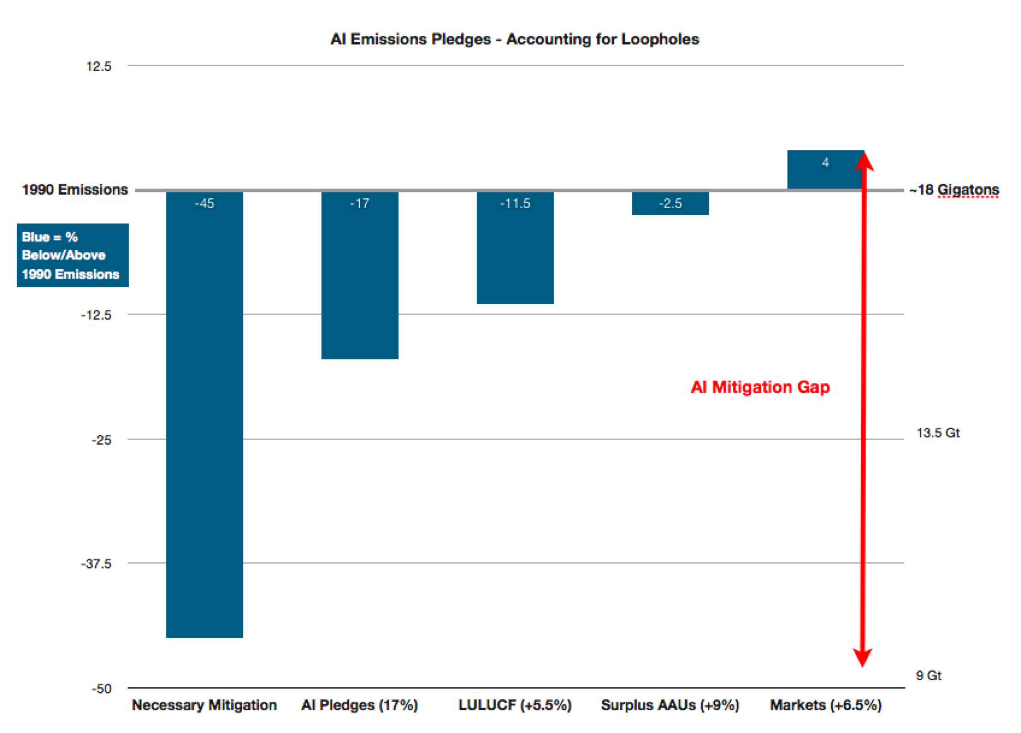
In sum, the inadequate pledges by Annex I Parties (17-25% from 1990 levels by 2020; and 12 to 18% if the United States is included), combined with the loopholes, give rise to a major gap in terms of mitigation – and credibility. Current pledges are an abrogation of the Annex I Parties’ responsibility, and would further increase the risk of dangerous climate change.

The scale of Annex I Parties’ pledges must rise, and the loopholes must be closed, in order to ensure the integrity and credibility of Annex I Parties’ aggregate emission reductions. A failure to address the loopholes satisfactorily would:

- Substantially add to the risks of dangerous climate change;
- Even more unfairly place mitigation and adaptation burdens on developing countries; and
- Result in an even larger unfair taking of the atmospheric space by developed countries.

To address this, a systematic study and accounting of each of these loopholes, and their combined effect, must be carried out immediately to determine their implications for the level of actual domestic emission reductions to be achieved by Annex I Parties in aggregate, and the associated impact on burden sharing by non-Annex I Parties. The loopholes must then be closed through appropriate CMP decisions in Cancun. Alternatively, the aggregate emission reduction commitments of Annex I Parties for the 2nd commitment period should be increased by the sum of the loopholes.

Closing the loopholes, and increasing the scale of Annex I ambition, will avoid shifting the burden of mitigating and adapting to climate change further towards developing countries. The loopholes are inconsistent with the letter and spirit of Annex I commitments under the Convention and its Kyoto Protocol, and will drastically increase the grave and growing risk of dangerous climate change.

Discussion draft

This paper was presented at the in-session workshop on the scale of emission reductions to be achieved by Annex I Parties in aggregate and the contribution of Annex I Parties, individually and jointly, to this scale at the 13th session of the Ad hoc Working Group on Further Commitments for Annex I Parties under the Kyoto Protocol, 2 August 2010, Bonn.

The paper and related powerpoint slides are available at: http://unfccc.int/kyoto_protocol/items/5685.php

Endnotes

¹CAN International, “Emissions Reduction Must Be Put at the Heart of Developed Country Climate Obligations on Forests” 2 June 2010.

²ECO, “Minding the LULUCF forest accounting gap” NGO Newsletter, Issue No. 1, Vol. CXXV, 2 August 2010.

³Point Carbon, “Assigned Amount Unit: Seller/buyer analysis and impact on post-2012 climate regime” 26 October 2009. http://www.climnet.org/index.php?option=com_docman&task=doc_details&gid=1512&Itemid=2

⁴Rogelj, Joeri, J. Nabel, C. Chen, W. Hare, K. Markmann, M. Meinshausen, M. Schaeffer, K. Macey, N. Hohne (2010). “Copenhagen Accord pledges are paltry” Nature, Vol. 464, 22 April 2010, 1126-1128.

⁵Schneider, Lambert (2007). “Is the CDM fulfilling its environmental and sustainable development objectives? An evaluation of the CDM and options for improvement” Öko-Institut, Institute for Applied Ecology, 5 November 2007. www.oeko.de/oekodoc/622/2007-162-en.pdf

⁶Sustainability Council of New Zealand, “Integrity Gap: Copenhagen Pledges and Loopholes” August 2010.

⁷UNFCCC, “Analysis of possible means to reach emission reduction targets and of relevant methodological issues” FCCC/TP/2008/2.

⁸UNFCCC, AWG-KP 13, “Available new data and information on their expected use in the next commitment period of land use, land-use change and forestry and emissions trading and the project-based mechanisms, including expected carry-over of units from the first commitment period to the next commitment period, as well as related assumptions made when presenting their pledges for emission reduction targets” 16 July 2010, FCCC/KP/AWG/2010/Misc.4.

⁹UNFCCC, AWG-KP 13, “Views on the topics to be covered and the organizations/experts to be invited to the in-session workshop on the scale of emission reductions to be achieved by Annex I Parties in aggregate and the contribution of Annex I Parties, indirectly or jointly, to this scale” 16 July 2010, FCCC/KP/AWG/2010/Misc.2.

¹⁰UNFCCC, AWG-KP 13, “Compilation of pledges for emission reductions and related assumptions provided by Parties to date and the associated emission reductions” 21 July 2010, FCCC/KP/AWG/2010/INF.2.

¹¹UNFCCC, AWG-KP 12, “Compilation of pledges for emission reductions and related assumptions provided by Parties to date and the associated emission reductions” 20 May 2010, FCCC/KP/AWG/2010/INF.1.

¹²UNFCCC. “Investment and financial flows to address climate change: an update” 26 November 2008, FCCC/TP/2008/7.

